SWOT Analysis

# Continental Biscuits Limited (CBL)

The SWOT analysis of Continental Biscuits Limited is part of my Business Analytics internship at Digital Empowerment Pakistan. This exercise helps in evaluating the company’s strengths, weaknesses, opportunities, and threats, providing insights that can assist in strategic decision-making and identifying areas for growth and improvement.

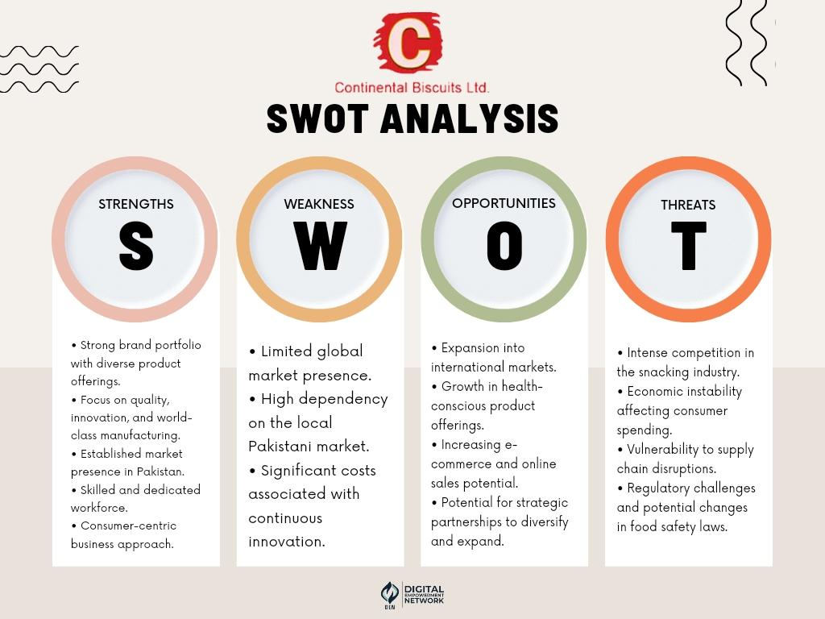

**Strengths:**

**Instructions**: Identify the internal attributes that give the company an advantage over competitors.

**Example**:

**Strong brand portfolio:** CBL has a diverse range of popular products, making it a leader in the snacking industry.

**Weaknesses:**

**Instructions:** Pinpoint the internal limitations or challenges that may hinder the company’s performance.

**Example:**

**Limited global presence:** CBL’s operations are primarily confined to Pakistan, restricting its growth potential internationally.

**Opportunities:**

**Instructions:** Highlight external factors or trends that the company could leverage to its advantage.

**Example:**

**E-commerce growth:** With the rise of online shopping, CBL can expand its digital presence to reach a wider audience.

**Threats:**

**Instructions**: Identify external risks or challenges that could negatively impact the company.

**Example:**

**Intense competition:** The snacking industry in Pakistan is highly competitive, with many brands competing for market share.

This analysis provides a structured approach to understanding CBL’s position in the market and identifying strategic actions for future growth.